All About The COVID Vaccine
By: Abigail Suter
According to the World Health Organization, vaccines work by preparing the body’s immune system to fight off viruses and bacteria which save millions of lives every year. Vaccines are a critical tool in the fight against COVID and to help us get back to normal.
←Image courtesy of the Wisconsin Department of Health Services found here
The COVID vaccines have undergone the most intensive safety monitoring in U.S. history. There may be possible side effects after receiving the COVID vaccine like tiredness or soreness in the affected area, but these should go away after a few days. The reason that your body does this is because your body is building protection, and this is completely normal. When it comes to COVID-19, everyone experiences symptoms differently and in some cases COVID-19 can be life threatening. There is no way to tell how your body will react if you get COVID-19, so why take that chance?
Click the link for more information on possible side effects.
Here is additional information regarding each individual vaccine:
-Pfizer-BioNTech -Moderna -Johnson & Johnson’s Janssen

Myths & Facts
Myth: The creation of the COVID vaccine was rushed, so it may not be safe.
Fact: There are so many reasons that the vaccine was produced so quickly one being that there have been years of prior research done on previous viruses, which means that scientists aren’t starting their research from scratch. Additionally, the production of a vaccine started before there was any formal approval to do so because of the urgency of our situation, and thus this reduced time between approval and distribution.
Myth: The COVID vaccine can cause a severe or even fatal allergic reaction.
Fact: As with the risk of any medication, there is a tiny chance that some people may experience an allergic reaction and the risk is extremely small. This is why healthcare workers do ask you to stay 15 minutes after your vaccination to monitor you, and to be able to take action if a reaction occurs.
Myth: There is no need to get the COVID vaccine if you have already received a flu vaccine.
Fact: It is important to get the flu vaccine, but it does not protect you from COVID-19 because these are two different viruses. There is no evidence that the flu vaccine protects against COVID.

Myth: The COVID vaccine can cause female infertility.
Fact: A key ingredient in the main vaccines at this time (Pfizer and Moderna) is mRNA which trains your body to produce proteins to combat COVID-19. This has no effect on the placenta and has no adverse effects on pregnancy. There have been a lot of false claims about this topic on sites like “Health Money & News”, which has also claimed that COVID isn’t real and that wearing a facemask will cause irreversible brain damage. It’s safe to say that these claims have no evidence to back them up.
Myth: It’s better to just get COVID to gain immunity.
Fact: COVID-19 can cause serious health issues that can be long-term or even fatal, and it still isn’t clear at this time if you will even get immunity this way. This can be avoided by getting vaccinated because this allows you to build immunity without suffering the damaging effects of the virus itself.
The myths & facts listed above can be found here.
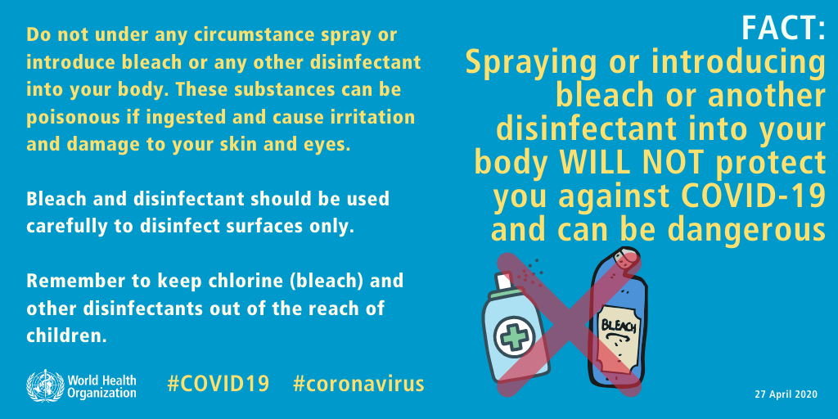
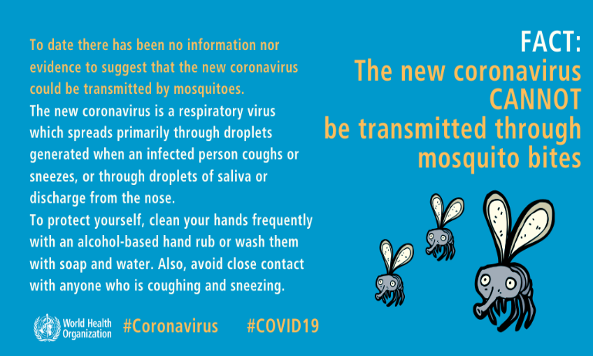
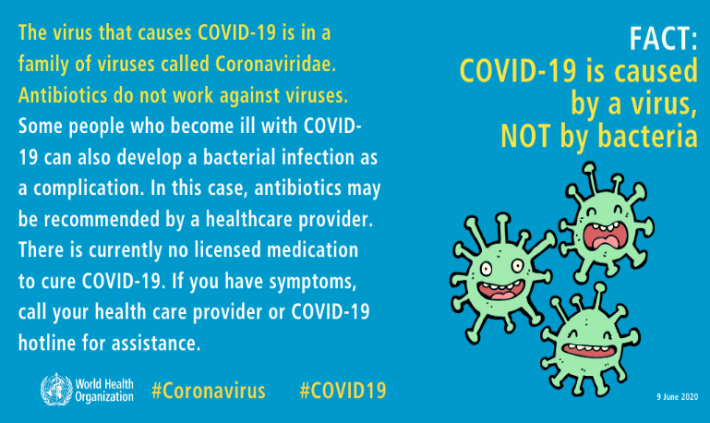
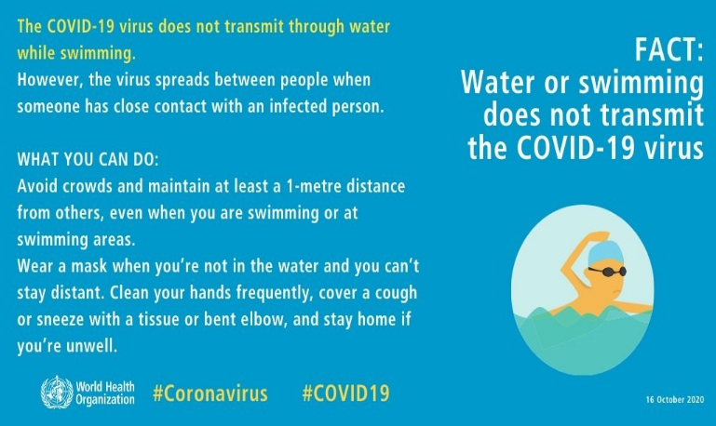
↑The graphics above can be found here courtesy of the World Health Organization.
Kenosha County Division of Health COVID-19 Response Hub
How to find a COVID vaccine near you
COVID data tracker with easy to use visualizations and graphs.

