**EMAIL SIGNATURE ANATOMY**

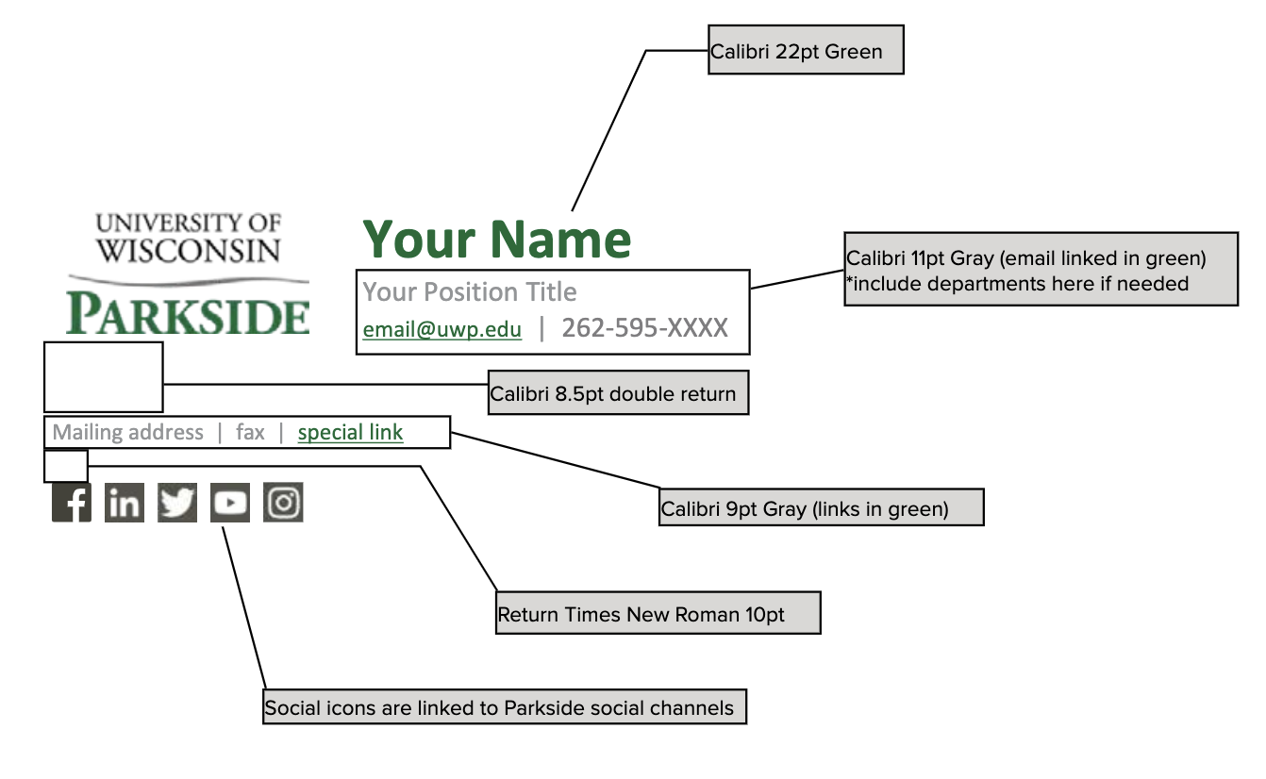

**EMAIL SIGNATURE TEMPLATE**

Replace words and hyperlinks in the template below with your information and links. Be sure to keep formatting as detailed in the EMAIL SIGNATURE ANATOMY. Then, copy everything and paste into the Signature editor in Outlook. Text and images below are in a table. If absolutely necessary, you may adjust the width for the table or columns.

|  |  |
| --- | --- |
| [University of Wisconsin-Parkside](https://www.uwp.edu/) | **Your Name**  Your Position Title  email@uwp.edu  |  262-595-XXXX |
|  | |
| Mailing address | fax | special link | |
|  | |
|  | |

Social media icons are optional. You may replace Parkside links with department social links.

Don’t restate University of Wisconsin-Parkside in signatures with logo.

Don’t include department if it is in your title or obvious.

Peppy or inspirational quotes and multitude of titles go under the entire signature (below icons or address)

**COMPLETED EXAMPLES**

|  |  |
| --- | --- |
| [University of Wisconsin-Parkside](https://www.uwp.edu/) | **Jane Doe**  Email Signature Czar  email@uwp.edu  |  262-595-2539 |
|  | |
| 900 Wood Rd. Kenosha, WI 53144 | 262-595-2539 | [styleguide](https://www.uwp.edu/explore/offices/marketing-and-design/styleguide/) | |
|  | |
|  | |

|  |  |  |
| --- | --- | --- |
| [University of Wisconsin-Parkside](https://www.uwp.edu/) | | **Fabrice Conte-Williamson**  Assistant Professor of Theatre Arts Recruitment Coordinator  Directing, Theatre History and Literature, Performance  [contewil@uwp.edu](mailto:contewil@uwp.edu) |
|  | | |
| [Student Perspective](https://www.uwp.edu/apply/virtualtour/)  |  [Major](https://www.uwp.edu/learn/programs/theatrearts.cfm)  |  [Department Site](https://www.uwp.edu/learn/departments/theatrearts/)  |  [Performances](https://www.uwp.edu/engage/theatreperformances.cfm) | | |
|  | | |
| THEATRE ARTS: |  | |

|  |  |
| --- | --- |
| [University of Wisconsin-Parkside](https://www.uwp.edu/) | **Dalinda Galaviz**  HR Business Analyst  [galaviz@uwp.edu](mailto:galaviz@uwp.edu)  |  262-595-2263 |
|  | |
| 900 Wood Rd, Kenosha, WI 53144 | Tallent Hall, Room 280 | [Website](https://www.uwp.edu/explore/offices/humanresources/) | |
|  | |
|  | |